August 8, 2004 | International Student Report - Itay Lewinsky  Israel's Security Fence, Israel's Aparteid Wall

http://www.peaceboat.org/english/voyg/pv/46/lob/0808_11/index.html

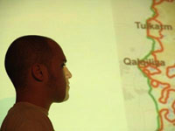
Itay Lewinsky giving a presentation

The audience crowded around Itay Lewinsky so tightly people passing by stood on chairs, straining to catch his words. For Lewinsky, an Israeli human rights activist and an International student on the 46th voyage, this is very different from the crowd of Israelis soldiers who have often appeared at demonstrations he takes part in. Lewinsky first started off as an animal rights activist when he was 14 years old. Now 20, his activism centers on demonstrating against the Israeli Wall and acting as a human shield for Palestinians. "We are in demonstrations so that the army won't shot the Palestinian demonstrators. And we go into houses that are about to be demolished, because if only Palestine people are inside, they demolish it anyway," Lewinsky said.
The result of this activism ranges from physical confrontation and stun grenades to rubber bullets and live bullets. "We never try to harm soldiers, because it's obvious they are safe. But still they are using extreme violence when we are harming fences or even when we are walking peacefully in a demonstration," said Lewinsky, who has lost sight in his left eye from a rubber bullet fired by an Israeli soldier. There is little room in Israeli society for people who disagree with the government's policy towards Palestinians. "In society we are treated as traitors, people I went to school with won't talk to me," he said, admitting his views are not mainstream among Israelis. "It's because I've visited many places in Palestine and I've seen what's being done by Israel."
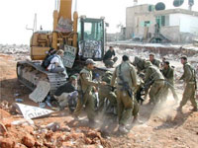
Israelis trying to block construction of the Wall (Photo Courtesy of Itay Lewinsky)
Except a detailed education on the Holocaust, Lewinsky said Israelis learn nothing about the everyday reality of Palestinians and much about defending Israel. "This is built on the idea that 'everybody hates us', so we have every right to do anything in the name of self-protection." Lewinsky, however, doesn't see the region's conflict as a clash of civilizations as some try to make it seem. "In my view, it's not Israelis against Palestinians. The real struggle is between power and people - whether it's Israelis against the Israeli government or Palestinians against the Palestinian government...To control people you must have an enemy, because if there is no enemy, than the government is the enemy," he said.
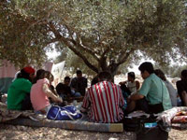
A joint camp Palestinians and Israelis made to block construction (Photo Courtesy of Itay Lewinsky)
According to Lewinsky, the Jewish experience of the Holocaust is leading to an environment closed to certain realities, with even constructive criticism being equated to anti-Semitism. "The government is always saying that we have this country we must defend, but the most dangerous place now for Jews is this region of the world," Lewinsky pointed out in an open Q&A session for Peace Boat participants. International perception of the conflict is equally skewed, largely because Israel, with its close relationship with the US, controls the image of the conflict. "My idea of the world's view and the ideas the media is giving people, Israel is like a desert and these two people are standing there throwing stones at each other," he said.
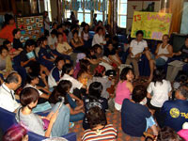
Lewinsky answering Peace Boat participant's questions
Israelis defense policy is being manifested in the construction of a 425 mile (630 km) barrier of high concrete walls, razor-wire fences, electronic surveillance system, a no-go buffer zone, tank patrol roads, trenches and watch towers. Lewinsky's presentation focused on the complex, which runs mostly along the pre-1967 war border, although some of it dips into the West Bank. The barriers essentially separate the Palestine people from their land, turning a formerly ten minute car ride into a five hour ride in some places. "We call it the apartheid wall and the Israeli government calls it the security fence," he said. Although the Israeli government claims that it does not annex Palestinian territories or change the status of residents, some Palestinian villages have lost up to 95 percent of their agriculture land. "But the government doesn't tell Israelis that," Lewinsky said. According to International Solidarity Movement, a group of mostly foreigners working as human shields, after "the completion of the wall, approximately 43% of Occupied West Bank land will be de facto annexed to Israel." "But they are changing things all the time, so it's very hard to give an exact number," Lewinsky said.
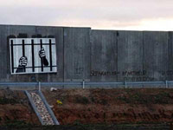
A section of the concrete wall (Photo Courtesy of Itay Lewinsky)
On its website, the Israeli government said the barriers will cause "minimum disruption" to the populations daily life. The Israel Defense Force claims that there are 73 gates, but a UN study in April of 2004 on the impact on the West Bank reported that out of 53 narrow agricultural passageways, pedestrian and trade gates located along its route, only 15 are open to Palestinians with permits. Along with strict and sometimes arbitrary curfews, Amnesty International in its report for 2004 said the Wall effectively cuts of "hundreds of thousands of Palestinians from essential services in nearby towns and villages and from their farming land - a main source of subsistence for Palestinians in this area." With the unemployment running close to 50 percent and two thirds of the population living below the poverty line, there is an increasing number suffering from health problems and malnutrition. "The government doesn't forcibly remove these people. But if you can't farm and there's no other work, these people have to leave and become refugees. Actually, its terrorism, but a much bigger scale," said Lewinsky, who has also worked to force gates open that are supposed to open under Israel's own laws.
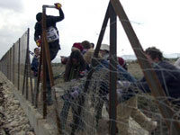
Israeli activist damaging a fence (Photo Courtesy of Itay Lewinsky)
On July 9th, just as the 46th voyage was preparing to leave, the United Nation's highest judicial body, the International Court of Justice (ICJ), declared by a 14-1 vote that the barrier, along its planned route, infringesî Palestinians rights and cannot be justified by national security and violates international law. The lone dissenter was U.S. judge Thomas Buerghenthal. The ICJ's written judgment expressed grave concern about the wall "which has involved the confiscation and destruction of Palestinian land and resources, the disruption of the lives of thousands of protected civilians and the de facto annexation of large areas of territory, and underlining the unanimous opposition by the international community to the construction of that wall." They also highlighted the "devastating impact" the project is having on the Palestinian civilian population and on the prospects for establishing peace in the region. Significantly, the ruling determined that the lands captured and annexed by Israel in the 1967 Middle East war are occupied territory, including East Jerusalem. "But because of the support of the United States they do whatever they want and ignore the ruling," he said.
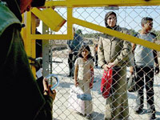
Palestinians waiting at a gate (Photo Courtesy of Itay Lewinsky)
At the political level, the conflict has high social costs, with much of the national budget going to buy weapons, the army and the ministry of security. At a family level, this translates into one of the world's strictest military service requirements, with three years for men and two years for women, plus reserve duty of about one month in every year until the age of 54. Currently, conscientious objector status is recognized in both the Universal Declaration of Human Rights and the European Convention on Human Rights. According to Lewinsky the reality in Israel is still far from those conventions. "In Israel conscientious objectors go to prison for around two months, with some being imprisoned for more than a year. "It's different for girls, sometimes they can get out of it. But It's a fact any objectors go to prison." Lewinsky said that in Israel, this has created an environment where peace activism is repressed, so he identifies himself with a sub-culture opposed to Israeli's current society. "Israel is really fascist and very racist. If you can imagine a nation where everyone has a firearm and is occupying another country. So it's a very violent, militant culture," he said.
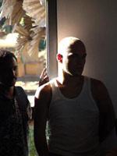
Itay Lewinsky in Sri Lanka for Peace Boat
Despite his activities, however, he said there is nothing extraordinary about being an activist, especially with the Internet as an independent media source at anyone's fingertips. "All you have to do is to think critically and not believe everything that you are told. When you go to Palestine and talk to the people you discover truth has many faces." Between suicide bombers and violence done in their name, he said Israelis and others can't afford to just watch the TV and complain. Because of his direct experiences and the good friendships with Palestinians he has formed, Lewinsky won't accept the message of violence as a solution - nor apathy. "If thought it was impossible I would just go into the army and do what I am told."

Isreali Lewinsky and Palestinian International Student Iba Farrah talk

