August 6, 2004
International Student Report - Iba Farrah
The Wall must Fall: Separation and Conflict

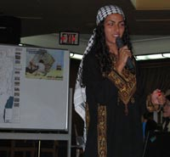
Iba presenting onboard Peace Boat

http://www.peaceboat.org/english/voyg/pv/46/lob/0806_14/index.html

To Iba Farrah, a Palestinian international student onboard Peace Boat, the "racism separation wall" is a symbol of the extreme segregation that exists between Israelis and Palestinians, and only adds to the mistreatment, violence, and intolerance shown towards Palestinians since the state of Israel was created in 1948. The construction of 650-kilometer concrete and barbed wire wall began in 2002 (encircling hundreds of thousands of Palestinians in the West BanK) essentially creating the largest prison in the world. When the wall is completed, passage outside of the territory will cut Palestinians from families, resources, and land.
In a presentation to Peace Boat, Iba pointed out that the construction of a 'barrier' between Israelis and Palestinians begins at a young age, and that a segregated social structure leads to continuous conflict and intolerance. Children, both Palestinian and Israeli, rarely meet, attend separate school systems, and both are taught about the conflict from different educational viewpoints. However, Iba explained, for most Palestinian children the inequality they experience is the most impacting teacher. "For me, when growing up I never learned about conflict from books, but from my daily life." Adding, when it comes to most Palestinian children, "the only Israelis they see are soldiers coming to invade."
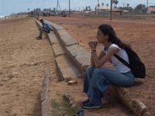
Iba in Sri Lanka with Peace Boat
Living in East Jerusalem with a degree in genetic engineering from the Jordan University of Science and Technology, Iba is politically and socially active. While continuing her passion, conducting research in the field of cancer and genetics at Hebrew University, Iba's activism extends to the Palestinian Vision NGO, the Palestinian Center for Policy and Survey Research, and the Palestinian National Initiative against the Separation Wall. Iba believes that the completion of the wall will destroy any hope of real dialog between Israeli and Palestinian people. To stress the importance of cross-cultural relations Iba said, "The main point of the conflict is Israelis and Palestinians being separated from each other. I have had a special experience. Living in Jerusalem I have a chance to meet with Israeli people so we can talk. Other Palestinians don't have this chance."
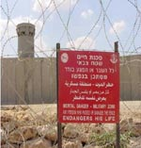
The West Bank Wall, in end will be 30 times the length, and twice the height of Berlin wall
Already judged illegal by the United Nations International Court of Justice in The Hague, the Israeli government justifies the wall's continued construction as a "temporary" security measure. The purpose is said to protect the two nationalities against the violence that began in the 2000 intifada. But, in terms of being a temporary structure, Iba said, building the wall takes serious manpower and resources: "The wall is claimed to be temporary, but at a cost of three billion dollars, this is not temporary." She believes its real purpose is to fragment the West Bank and Palestinian communities, and to ensure the permanence of illegal Jewish settlements (communities that now live inside the 1967 green line boundary of the West Bank). Displaying various maps of the walls construction, Iba showed how its awkward shape has been designed to keep 98% of the illegal Jewish settlements outside and separate the inside land into 3 main sections, and over 300 subsections. This will cut Palestinians from roughly 52% of their land.
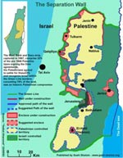
West Bank after wall is completed, note green line boundary of 1967
From 1947 until now, only 11% of the Palestinian's original land remains. Iba explained that the world sees the current conflict as a religious one, but, "you must be careful not to call it a religious conflict, it is not." In her view the conflict is about people losing their homes, land, lives, and livelihoods. From the 2000 intifada until the end of 2001, 2160 Palestinians had been killed (85% of which were civilians), and 41,00 thousand were injured by military invasions. In addition, recent shelling, bombing, and giant bulldozers have rendered 12,000 people homeless in 2003 alone. As a result many now suffer from severe malnutrition from being cut from jobs, farmland, water, communities, and family. In addition, Iba believes it is the current policy of the Israeli government to destroy anything that is Palestinian. This begins by cutting off resources such as water, and destroying olive groves, which are seen as a symbol of the Palestinians.
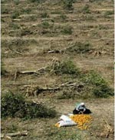
Olive tress - in one year, more than 1 million trees were uprooted
Explaining the effects of this military activity, Iba said, that currently 75 percent of Palestinians are living below the poverty line, and 30 percent of these children are malnourished - both numbers representing millions. Along with being cut from resources, normal life for Palestinians is constantly being disrupted. There have been over 650,000 Palestinian prisoners since 1967, and many arrested were under 18 years old. Personally this has affected Iba and here family, but she pointed out that this is not uncommon; almost all families are affected by arrests, torture, and imprisonment.
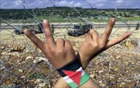
Hands in front of wall
So what can be done? "There are two nations living within the same borders," Iba explained, but this seems to be continually disregarded by the Israeli Government. Often the International community has intervened to broker peace talks between the two sides, but this has failed to achieve a plan with any lasting success. "All of the time the International community offers help, but only help for the Palestinians to survive, or lessen the suffering. It is never more than that," said Iba. "They cannot give Palestinians land or help refugees to go to their homeland - they offer tents and food, but that's all."

Jing Jing, Iba and Jasna Bastic, coordinator of International Student Program
As a solution to the conflict, Iba feels that first; Palestinians need to collectively unite to change current policies. With many different resistance movements, Iba feels this reflects that Palestinians are not united. The two major parties, the Palestinian Authority and Hamas are opposed. The Palestinian Authority represents the Palestinians on an international level, while Hamas adopts a different policy of resistance. The second solution to resolve the conflict, Iba replied, is if both Israelis and Palestinians come to a basic understanding, beginning with the wall. "For peace talks to be carried out, and the current conflict to end, the Israeli government must put an end to the wall." But now Iba believes, "the anger is growing and growing, because this wall kills all forms of hope. Me and all Palestinians maintain this idea that we must have this hope." To reach a solution to the conflict Iba said, "I think all Palestinians and Israelis need to think together."

