Don't Dance with Israeli Apartheid
31 July, 2012
Friends of Al Aqsa
http://www.foa.org.uk/campaigns/dont-dance-with-israeli-apartheid

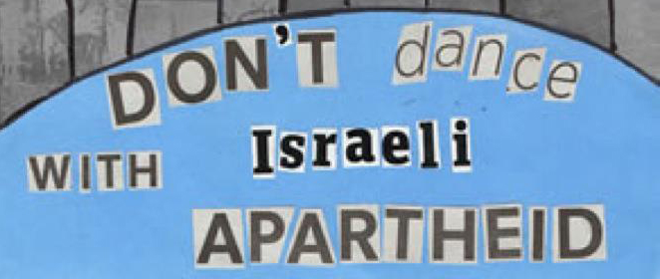
The Don't Dance with Israeli Apartheid campaign, which FOA is part of is calling for the boycott of the Batsheva Dance Company when it embarks on its UK tour in August.
Batsheva is funded by the Israeli state and is part of PR exercise designed by their Ministry of Foreign Affairs known as 'Brand Israel'. Its aim is to whitewash Israel's human rights abuses and violations of international law, creating a false image of a 'normally' functioning, democratic country.
Batsheva are scheduled to perform at the Edinburgh International Festival at the end of August and then to tour the UK visiting Salford, Birmingham, Bradford, Leicester, London, Brighton and Plymouth.
Take Action
1) We request you to write a letter (template letter available) to your nearest venue which is scheduled to host Batsheva asking for the invitation to be withdrawn due to the apartheid state it represents.
Template letter to your local venue is ready, you just need to add your contact details.
2) We will be organising protests outside the venues to highlight the international law and human rights abuses perpetrated by the state Batsheva represent. Keep an eye out for an Action Alert.

