Check The Label - Boycott Israeli Dates
May 25, 2012
http://www.foa.org.uk/campaigns/check-the-label

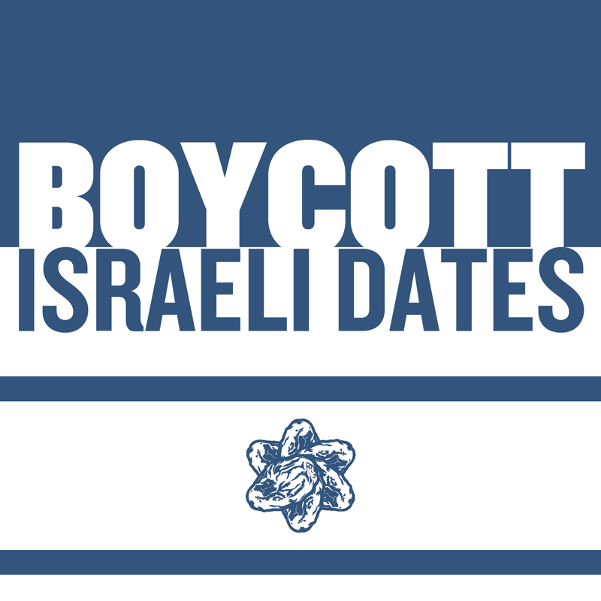
This Ramadan, Don't Break your Fast with an Israeli Date
Ramadan is a time of year when we remember those who are less fortunate than ourselves. It would be an affront if at such a time we helped support oppression
Every year, Israel exports millions of pounds worth of dates to the world, which many people unknowingly buy and use to break their fasts. These dates are grown in illegal settlements in the West Bank and the Jordan Valley, on land that has been stolen from Palestinians. By buying these dates, we are in fact helping Israel to continue its occupation and oppression of the Palestinian people.
For this reason, Friends of Al Aqsa will again be launching the ‘Check the Label’ Campaign.
Check The Label
Most of the major supermarkets will stock dates produced in Israel, West Bank and the Jordan Valley. Dates produced in the West Bank and the Jordan Valley are from Illegal Israeli Settlements and should also be boycotted.
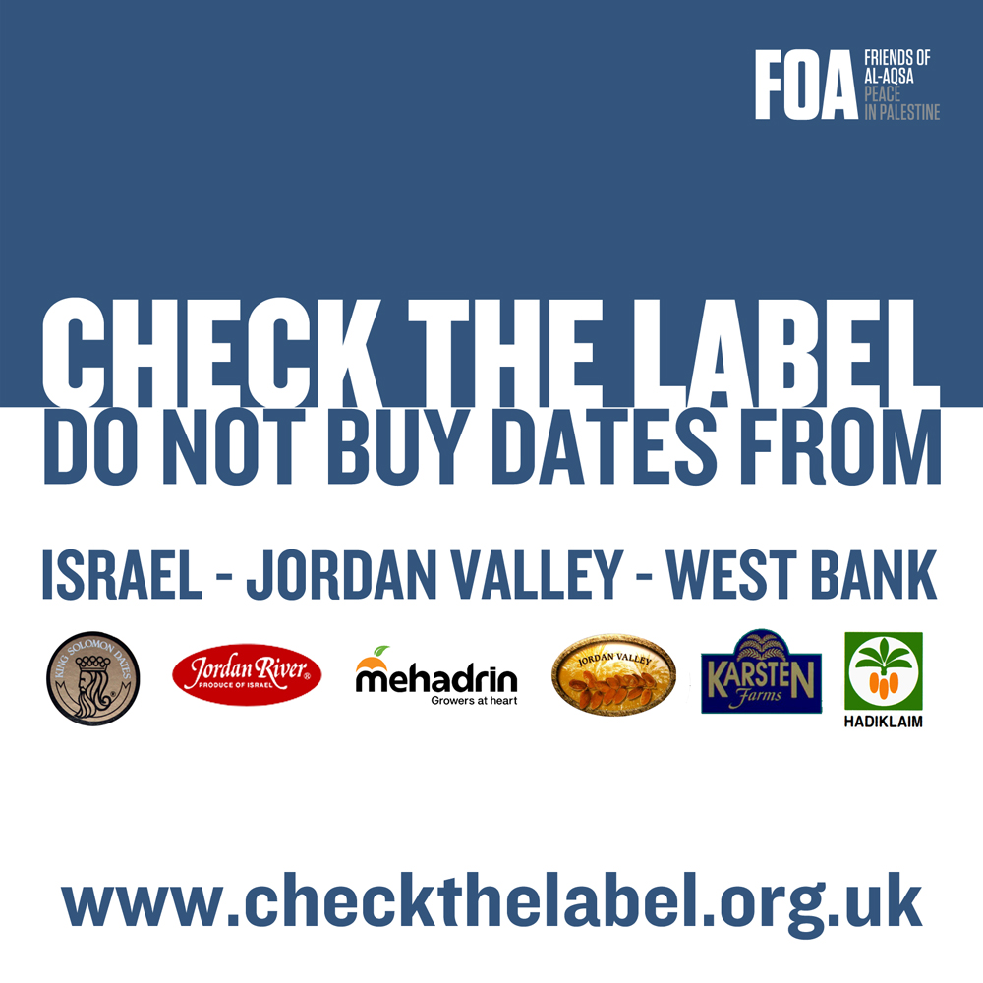
Making Money from the Occupation
- Dates were Israel's leading fruit export, most of which come to Europe
- The total income for Israel from dates in a year is approximately €80 million.
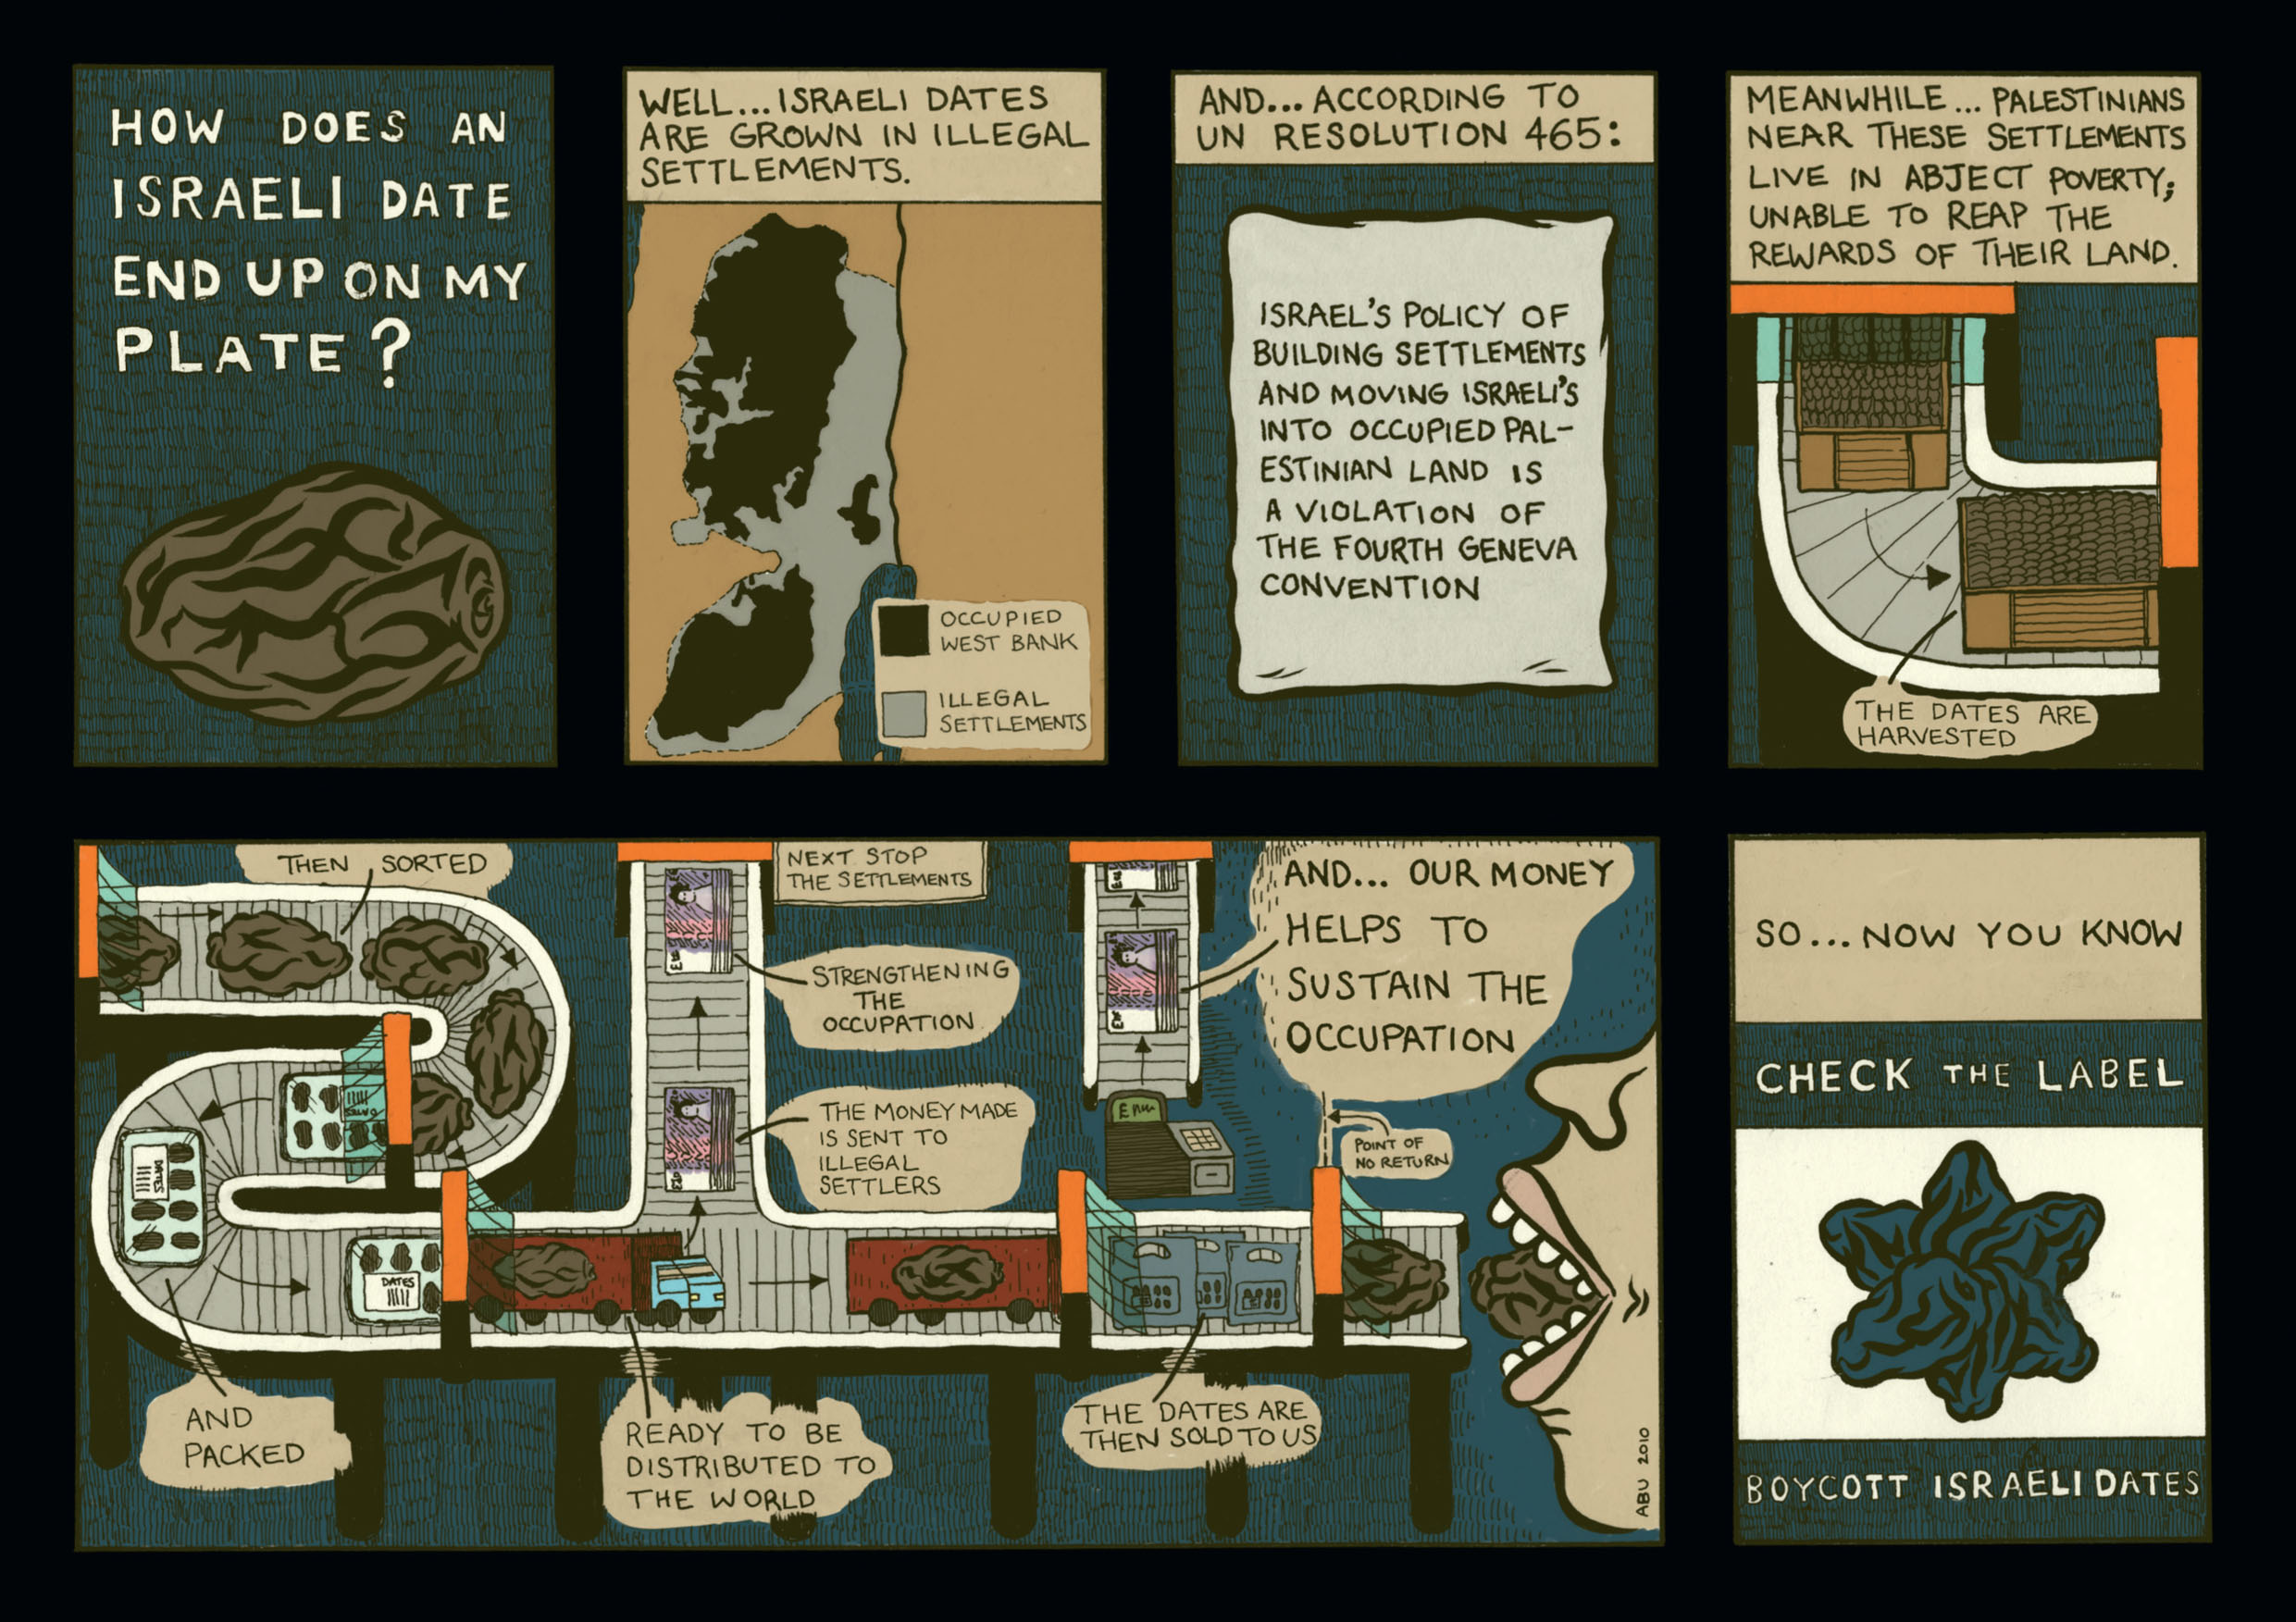
You can order your FREE Check The Label literature here

The Palestinian Call for Boycott Divestment and Sanctions
Inspired by the struggle of South Africans against apartheid and in the spirit of international solidarity, moral consistency and resistance to injustice and oppression,
We, representatives of Palestinian civil society, call upon international civil society organizations and people of conscience all over the world to impose broad boycotts and implement divestment initiatives against Israel similar to those applied to South Africa in the apartheid era. We appeal to you to pressure your respective states to impose embargoes and sanctions against Israel. We also invite conscientious Israelis to support this Call, for the sake of justice and genuine peace.
These non-violent punitive measures should be maintained until Israel meets its obligation to recognize the Palestinian peoples inalienable right to self-determination and fully complies with the precepts of international law by:
1. Ending its occupation and colonization of all Arab lands and dismantling the Wall;
2. Recognizing the fundamental rights of the Arab-Palestinian citizens of Israel to full equality; and
3. Respecting, protecting and promoting the rights of Palestinian refugees to return to their homes and properties as stipulated in UN resolution 194.
Click here for the full text and endorsements

Palestinian Workers
Israelis will claim that Palestinians are allowed to work on the land of these settlers and therefore they are provided with jobs and a boycott will harm them. In actual fact, these Palestinians are employed for paltry wages, and they are required to do the back-breaking work that the Israeli settlers will not do themselves. This means the Israeli settlers reap the rewards for the harvests while doing very little of the work themselves.
Palestinian children are employed by these settlers, and they are forced to work long hours under a hot baking sun for small sums of money. This exploitation means that these children miss out on an education.
Alternatives to Israeli Dates
There are plenty of varieties of dates from various other countries to break your fast. However if you would like Medjoul dates from Palestine and help the Palestinian farmers they are available from YAFFA. YAFFA source there dates from Palestine and FOA are helping YAFFA distribute dates this Ramadhan.
Another provider is Zaytoun, www.zaytoun.org

Get Involved
Volunteer to be an ambassador for the Check the Label Campaign. This will mean you will help promote the campaign in your area and take responsibility of distributing leaflets, speaking to shop owners and uploading photographs of shops where dates from Israel, West Bank and Jordan Valley can be purchased.
To volunteer email shamiul@foa.org.uk
Join our campaign FaceBook page to keep up to date with the campaign.
We are promoting Palestinian Medjoul Dates as an alternative.

There are two stages to this campaign:
Stage 1 – Contact and inform the wholesalers and shops.
Stage 2 – Contact and inform consumers.

Stage One
FOA have sent letters to over 1000 wholesalers and shops but we need your help to add the personal touch as that is the best method to encourage people to join the campaign.
There are 6 steps to this stage. We would like you to:
Preparation:
1. If you can try and involve family and friends in the campaign.
2. Print letters for Wholesalers and Shop Owners: Click here for the letter.
3. Order Check the Label posters and postcards from shamiul@foa.org.uk so you can put poster up on shop windows and leave postcards on the counter (with permission)
Method:
1. Identify the wholesalers, importers and shops in your area hand deliver the wholesaler/shop letters supplied by FOA. Inform them about Israeli human rights abuses (you can give them of FOA leaflets).
2. Tell wholesalers and shop owners about the concept of boycotting and how it has worked e.g. South Africa. Ask them to boycott dates from Israel, West Bank and the Jordan Valley. Explain West Bank and Jordan Valley are illegally occupied and buying dates from there would mean they are supporting the occupation of Palestine.
3. Let them know that they can buy dates from many other countries, but if they want to buy medjoul dates from Palestine they can contact shamiul@foa.org.uk, 0116 2125 441 or Zaytoun on 0207 609 5699 or Yaffa on 0844 3814988.
4. Keep in touch with the shops that you have approached and continue to encourage and support them to join the campaign.
5. Write down addresses of shops which agree to support the campaign so we can write a letter to them to thank them for their support.
6. Take pictures of the campaign and keep head office updated on your work in your locality.

Stage Two
Most of the people we have approached during the Check the Label campaign did not know dates are from Israel and also did not know that dates labelled West Bank or the Jordan Valley should also be Boycotted. Once they were told, the overwhelming majority of people were happy to join the boycott.
Boycott is about people power. We need your help to inform people they should ‘Check the Label’ and boycott dates from Israel, West Bank and Jordan Valley.
Preparation:
1. If you can try and involve family and friends in the campaign.
2. Print letters for mosques and organisations : Click here for the letter
3. Order Check the Label posters and postcards from here so you can put poster up on shop windows and leave postcards on the counter (with permission).
Method:
1. Identify Mosques and Community Centres in your area and hand deliver the Mosque/organisation letter supplied by FOA. Inform them about Israeli human rights abuses (you can give them of FOA leaflets).
2. Tell the mosque/ community centre contact about the concept of boycotting and how it has worked e.g. South Africa. Ask them to boycott dates from Israel, West Bank and the Jordan Valley. Explain West Bank and Jordan Valley are illegally occupied and buying dates from there would mean they are supporting the occupation of Palestine.
3. Ask them if you can leave leaflets at the entrance and put up a poster
4. Organise a time with friends and family to distribute outside the mosque after prayers, especially after Friday prayers.
5. Let FOA know when you are planning to distribute outside mosques so we can try and co-ordinate with other volunteers.
6. Contact your local newspaper and your local radio Ramadhan to let them know what is happening. Take photos when it is appropriate and send updates to shamiul@foa.org.uk

Free Campaign Literature
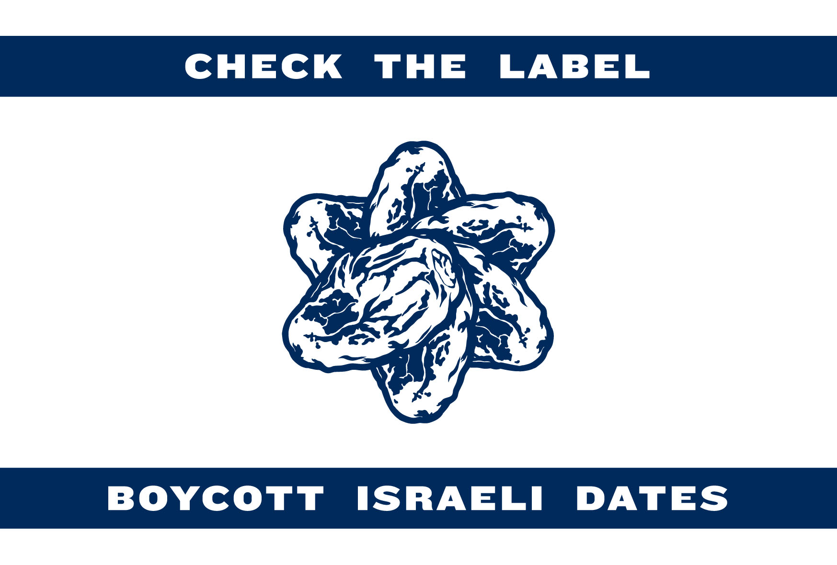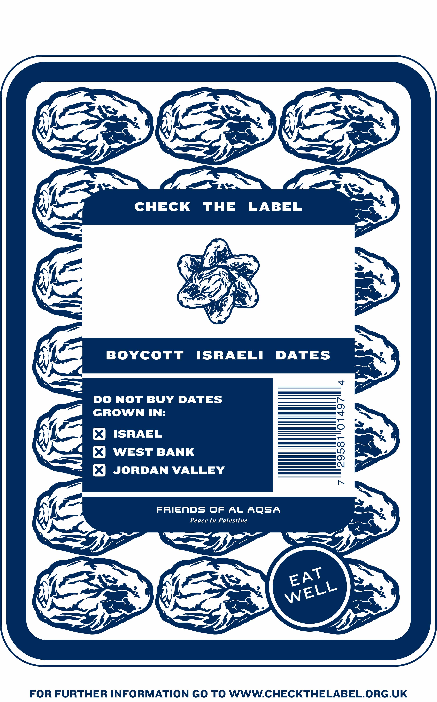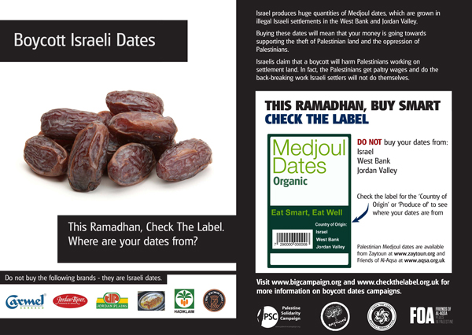

Campaign Cartoons
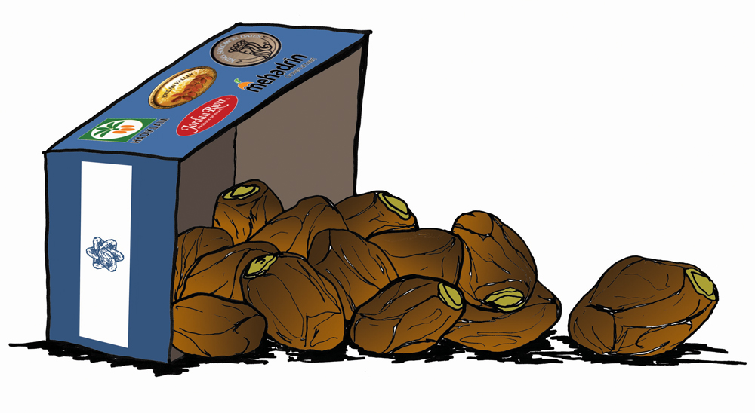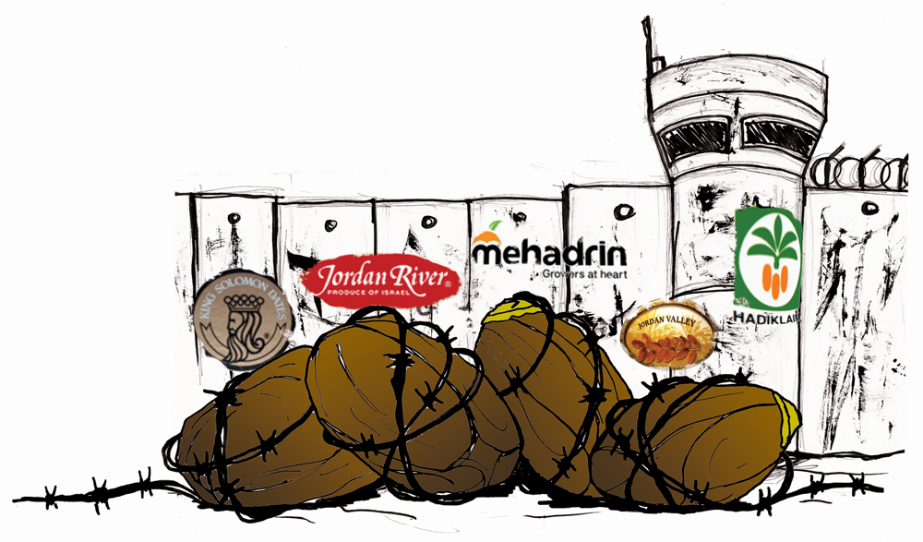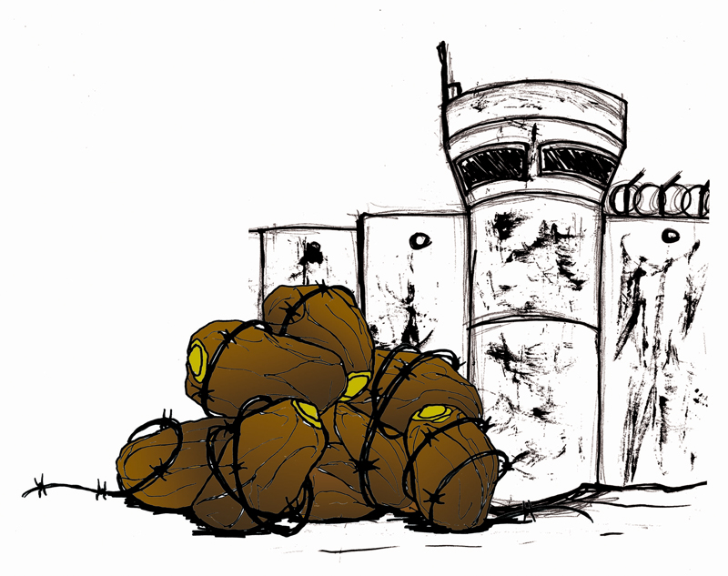
Check the Label Campaign Video

Buy Palestinian Medjoul Dates from Yaffa

