October 27, 2010
http://al-awda.org/alert-childrights.html

 | 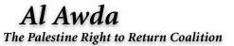 | 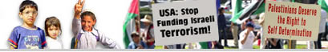

Home |  | About |  | Factsheet |  | Donate |  | Contact

October 27, 2010
For Immediate Release
Al-Awda Launches New Palestinian Children's Rights Campaign
Al-Awda, the Palestine Right to Return Coalition announces the launching of its Palestinian Children's Right Campaign. The mission of this campaign is to advocate for the immediate release of all Palestinian children detained in Israeli prisons, and to demand an end to the institutionalized and systematic abuse that these children are subjected to. The campaign has set as its goal the full restoration of Palestinian children's rights in accordance with international law including, but not limited to, their right to return to their homes of origin, to education, to medical and psychological care, and to freedom of movement and expression.
BACKGROUND
According to International Solidarity Foundation for Human Rights, 1,859 Palestinian children have been killed by the Israeli army since September 28, 2000. This is equivalent to more than one quarter of the 7,407 Palestinians who were killed by Israel in the same period. According to
mental health care organizations, approximately 80% of Palestinian children in the Gaza Strip display symptoms of post traumatic stress disorder and are in need of care. According to Defense Children International (DCI), a Geneva based non-governmental agency, about 700 Palestinian children in the West Bank alone are imprisoned by Israel every year. Further, based on a survey of 100 of these imprisoned children in 2009, DCI found that 69% were beaten and kicked, 49% were threatened, 14% were held in solitary confinement, 12% were threatened with sexual assault, including rape, and 32% were forced to sign confessions written in Hebrew, a language they do not understand. Such institutionalized and systematic mistreatment by the Israeli state of detained Palestinian children is considered torture by the United Nations under international law. Palestinian children in the West Bank and Gaza Strip are also systematically denied their right to education, to medical and psychological care, and to freedom of movement and expression. The total Palestinian population in the world today is estimated at about 11 million. Of these, 7.2 million including their children are living in forced exile or internally displaced, and are denied their right to return to their homes and lands of origin by the state of Israel.
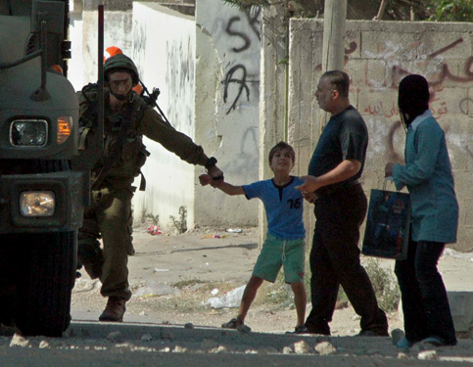
ACTION
The current situation and the severity of the systematic attack by the Israeli state on the children of Palestine demands a comprehensive and coordinated response. Therefore, Al-Awda, The Palestine Right to Return Coalition has decided to launch this campaign specifically to
demand the release of all Palestinian children from Israeli prisons and an end to all forms of institutionalized abuse of these children by the Israeli state. The committee, which has been formed to lead this campaign, intends to provide comprehensive education to the public, politicians and the media, and to organize effective advocacy for the rights of Palestinian children living under occupation, internally displaced or in forced exile in refugee camps and elsewhere. It intends to raise funds to support its work and help provide mental health services for children in need of such service.
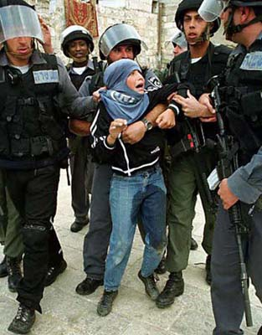
Among its goals, the committee intends to develop informational campaigns that will include regular updates, the production of factsheets, organization of lecture tours, film showings, rallies and protests, and other educational events. The committee will also organize meetings with politicians, newspaper and other media editors and editorial boards. It will publish calls and petitions to action, and press releases regularly. It intends to highlight the work needed for Palestinian child rights at the Annual International Al-Awda Conventions, and to reach out to community and student organizations, clubs, churches, mosques, etc. The committee also intends to coordinate its work with other children's rights organizations and to support all boycotts, divestment and sanction campaigns until children achieve their full rights in compliance with international law and legal norms and standards. The committee also intends to fundraise to support its work and to help provide mental health services for children in need of such service.
HOW YOU CAN HELP
We need your assistance with all aspects of this campaign!
Volunteer: If you would like to volunteer to help us with the action plan outlined above, please write to us at child.rights@al-awda.org explaining how and with what aspects you may be able to help.
Donate: To make a tax-deductible donation to help with the work of this campaign, please address your check or money order to Al-Awda - PRRC, PO Box 131352, Carlsbad, CA 92013, USA. Please indicate "Palestine Children's Campaign" in the memo line. Alternatively, you can submit your donation using your credit card online using the PayPal button at http://www.al-awda.org/donate.html. If you prefer, you may call us 9 A.M. to 5 P.M. Monday to Friday at 760-918-9441 with your credit card information instead.
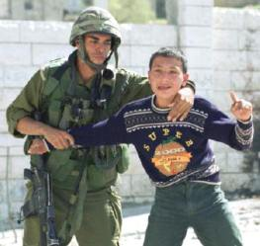
Organizations: We invite all organizations, who would like to advocate for the children's rights and would like to coordinate efforts with us on this campaign, to write to us at child.rights@al-awda.org.
Children are the most vulnerable members of any society. Israel's systematic attack on Palestine's children demands that all people of conscience stand up and take action in demand of their full rights!
Until return,
Al-Awda, The Palestine Right to Return Coalition
PO Box 131352
Carlsbad, CA 92013, USA
Tel: 760-918-9441
Fax: 760-918-9442
E-mail: info@al-awda.org
WWW: http://al-awda.org/
Al-Awda, The Palestine Right to Return Coalition (PRRC) is the largest network of grassroots activists and students dedicated to education and advocacy for the restoration of Palestinian human, national, legal, political and historical rights in full with particular emphasis on the right of Palestinians to return to their homes and lands of origin from which they have been dispossessed since 1948. PRRC is a not for profit tax-exempt educational and charitable 501(c)(3) organization as defined by the Internal Revenue Service (IRS) of the United States of America. Under IRS guidelines, your donations to PRRC are tax-deductible. To donate, go to http://www.al-awda.org/donate.html and follow the instructions. To become a member, go to http://www.al-awda.org/membership.html

Copyright Al-Awda/PRRC. All Rights Reserved. Legal Information.

